What should we do ?

Explore external data sources to provide broader insights into wellbeing factors.

Improve wellbeing measurement by finding new ways to look at data.

Identify multi-linked indicators that capture broader impacts on wellbeing.

Demonstrate how alternative data sources can complement traditional measures.

Valuable link: <https://www.regionalwellbeing.org.au/reports-to-date/> - Wellbeing

<https://www.act.gov.au/directorates-and-agencies/act-health/data-statistics-and-surveys/healthstats-act/epidemiology-publications/2022-act-general-health-survey-statistical-report>

OVERALL DATA:

<https://www.data.act.gov.au/People-and-Society/All-Wellbeing-Measures/b5kg-deh8/about_data>

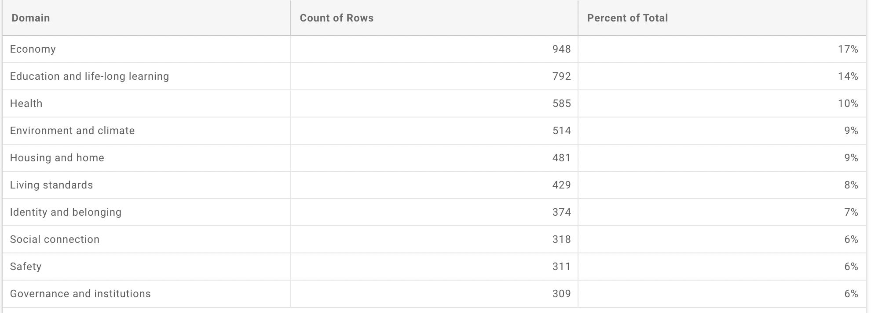

With those main domains

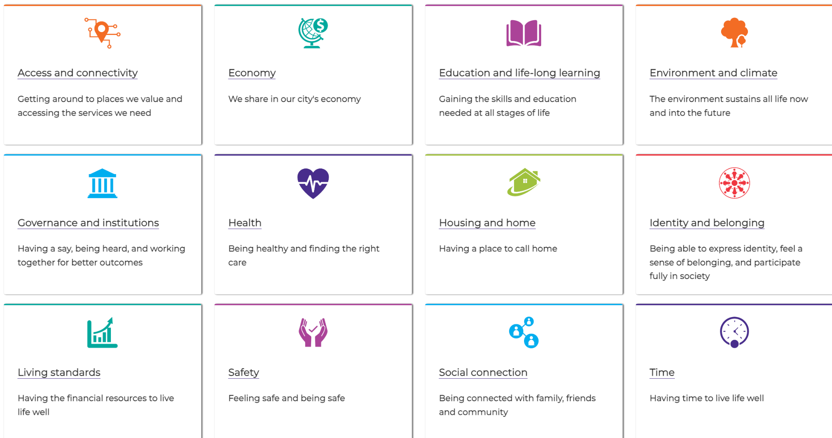

And those are domain from: <https://www.act.gov.au/wellbeing/explore-overall-wellbeing>

From the our lives report 2021: <https://ywca-canberra.org.au/wp-content/uploads/Our-Lives-Survey-Report-2021.pdf>

# 

# Well-being Framework

DATA Source: <https://www.canberra.edu.au/research/centres/hri/research-projects/regional-wellbeing-survey/regional-wellbeing-results-reports>

The **Personal Wellbeing Index (PWI)** provides valuable insights into how Canberrans perceive their quality of life across several domains. By measuring satisfaction in areas such as health, relationships, safety, community involvement, and future security, this indicator helps paint a picture of overall wellbeing. Key findings from the ACT population between 2019 and 2021 reveal several trends and disparities among different population groups:

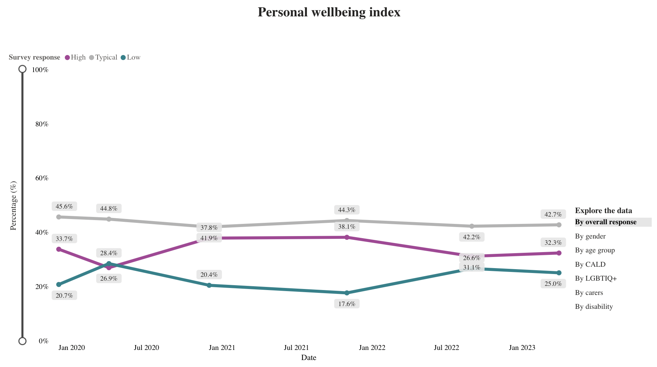

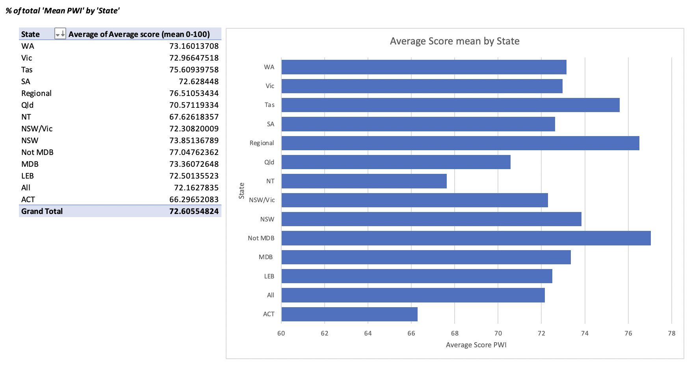

## 

Regression equation:

PWI= 0.1116+ 0.2761* “Household Financial Wellbeing” + 0.7812* “Community Economic Wellbeing” + 0.6732* “Equity and Inclusion” + (-0.4144)* “Access to Roads” + (-0.1211)* “Access to Financial Services”+ 0.1403* “Access to Telecommunications”+ 0.1895* “Crime and Safety”+ 0.1962* ‘Landscape and Aesthetics”+ (-0.2082)* Getting Involved in the Community+ (-0.3799)* Sense of Belonging + (-0.3013)* “Access to Health and Edu”+ 0.1480* “Perceived Environmental Health”+ 0.2254* “Lonliness Index”

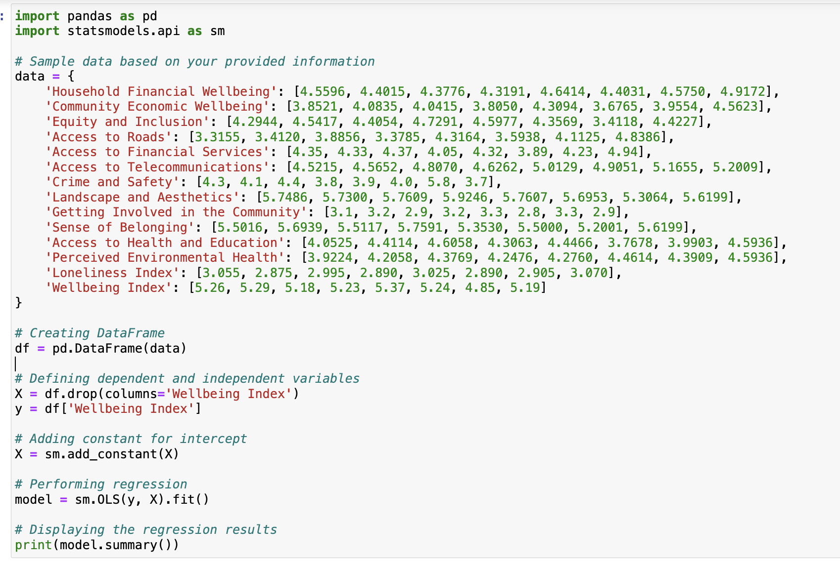

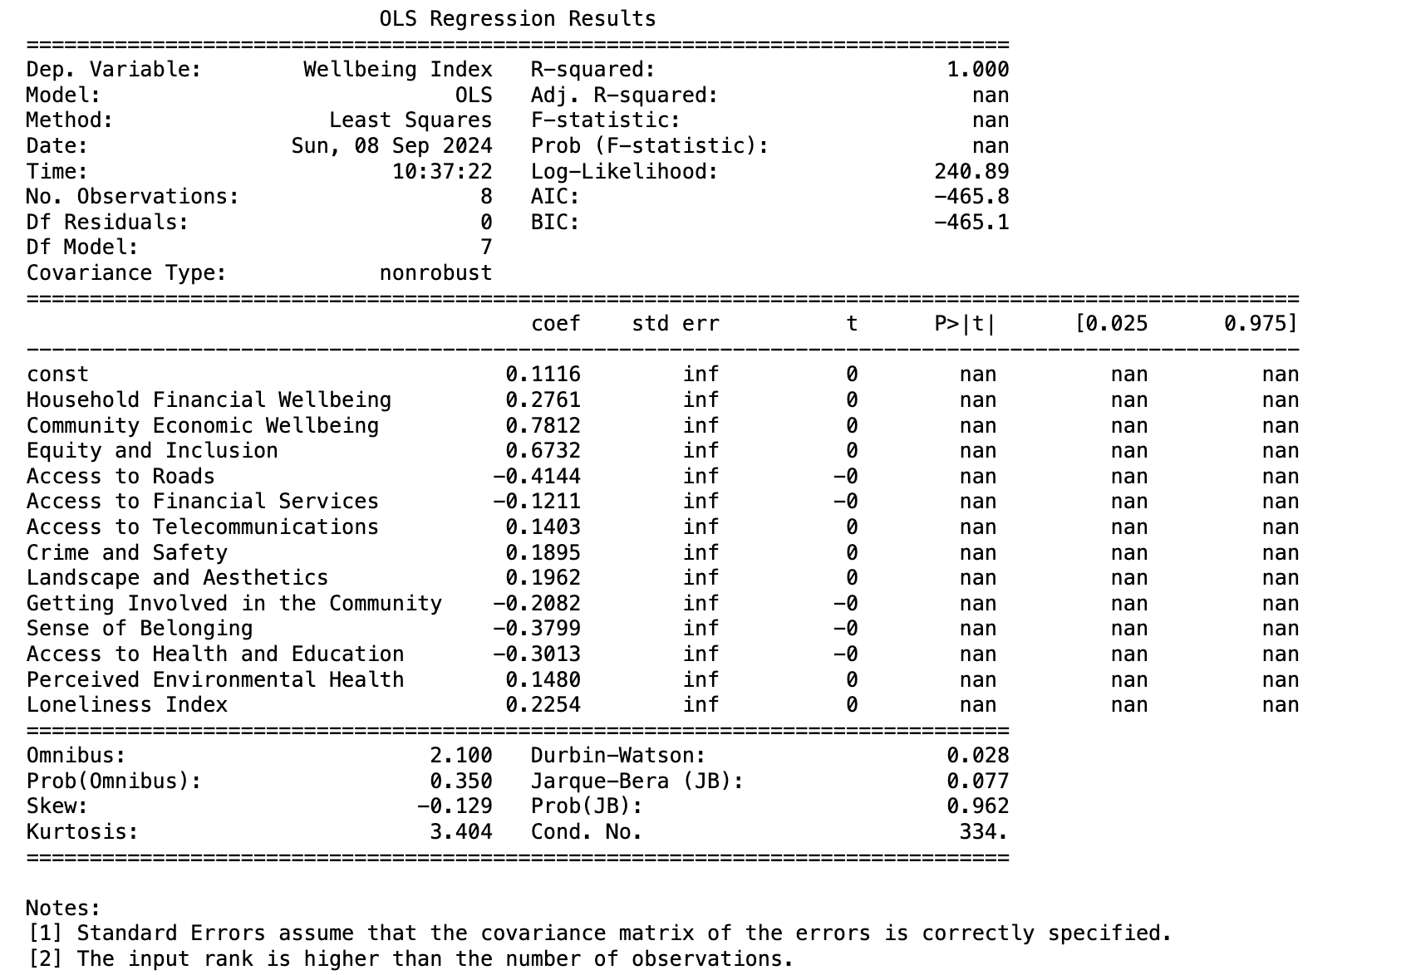

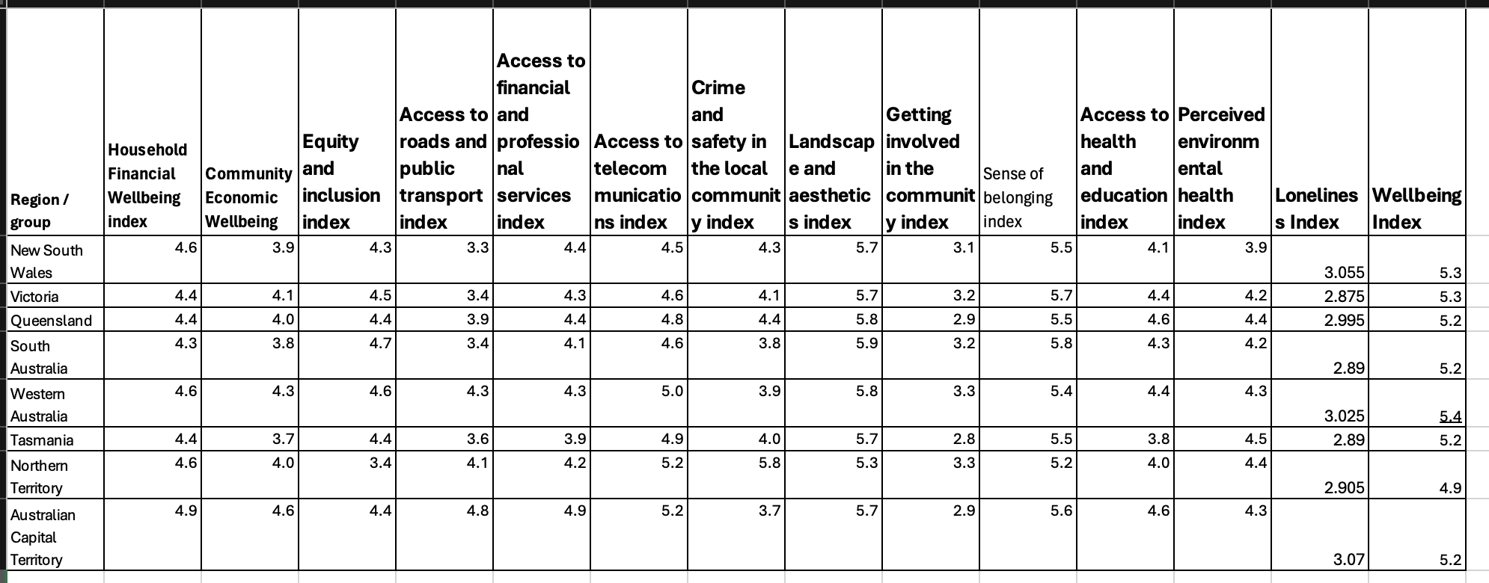

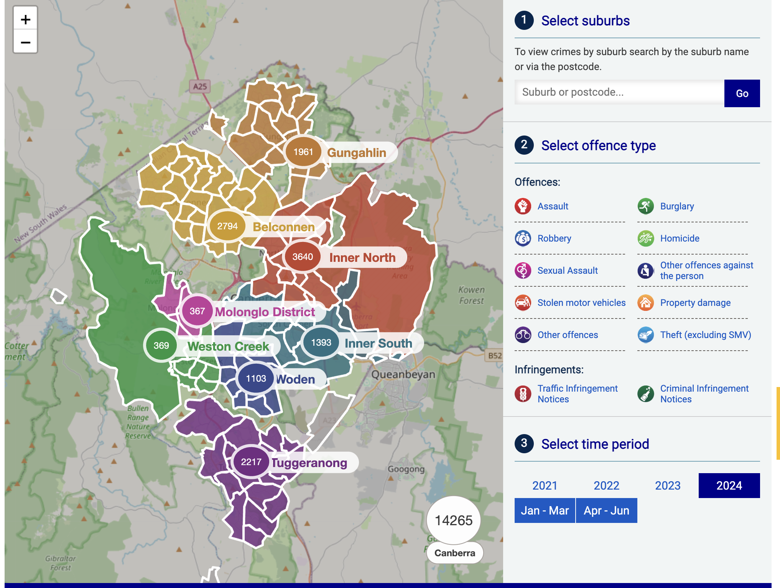

Source: [Crime Statistics | ACT Policing Online News](https://www.policenews.act.gov.au/crime-statistics-and-data/crime-statistics)

## Key Findings for the ACT Population:

1. **Average Wellbeing**:

The average PWI score for ACT adults in 2023 was 66.29, much lower than the national average of 72.16.

1. **Risk of Low Wellbeing**:

Certain groups were more likely to have low wellbeing:

* + - Those with disabilities (particularly mental health disabilities), carers, unemployed individuals, and people living alone or in apartments had the highest likelihood of low wellbeing.
    - People with teenage children aged 15-17 were also at greater risk.

1. **Groups with Higher Wellbeing**:

Older adults, couples without children, and those with children aged 5-14 had higher wellbeing scores.

Those who were born overseas - nonEnglish speaking countries.

Those who owned their homes outright or had a mortgage reported significantly higher levels of wellbeing compared to renters.

Other factors positively impacting wellbeing included living in freestanding houses and having young children in the home.

Some people persistently report lower rates of wellbeing, particularly those:

* living with disability
* with caring responsibilities
* identifying as LGBTIQ+.

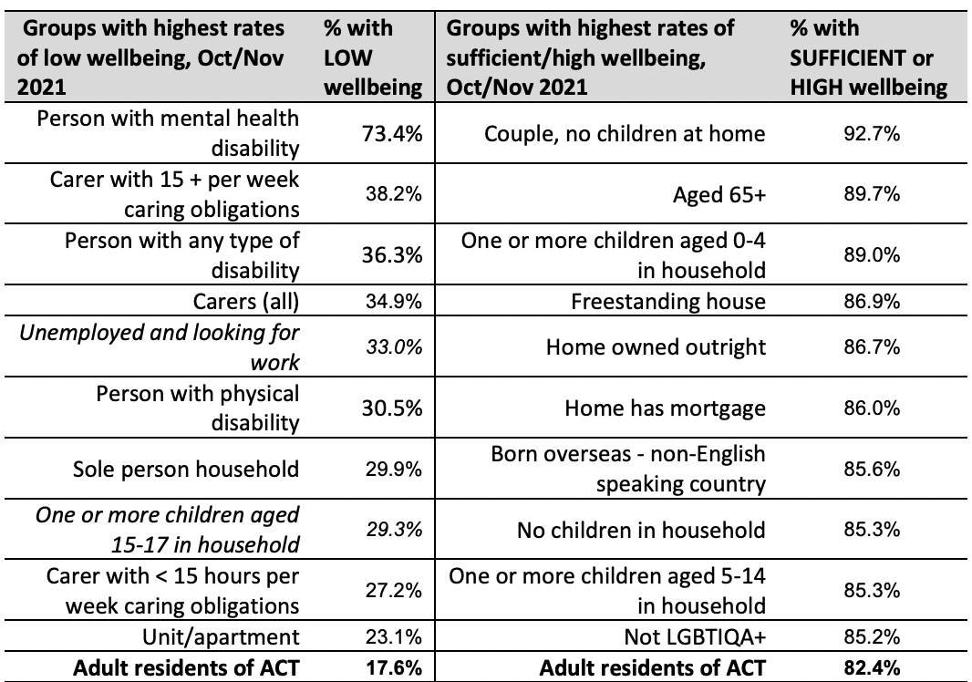

## SAFETY - Road Safety

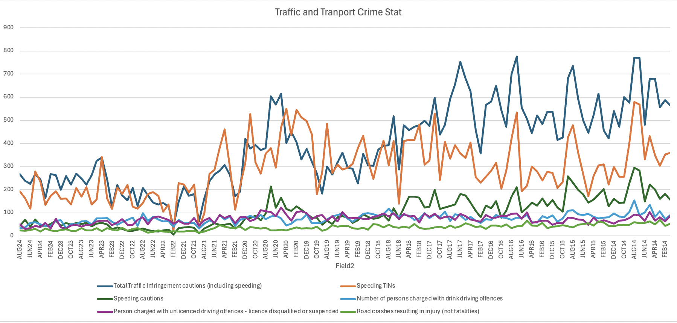

## SAFETY - DOMESTIC VIOLENCE

## HIGH PERSONAL WELLBEING

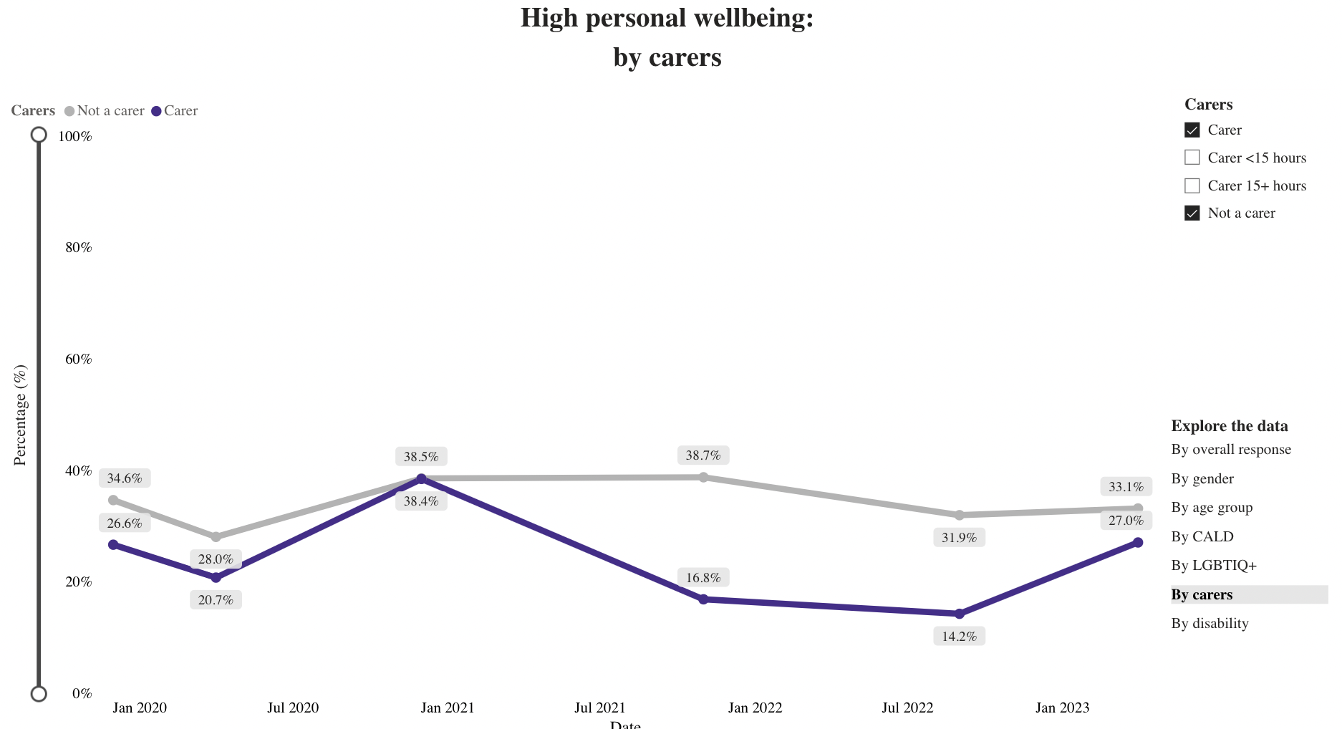

MENTAL HEALTH

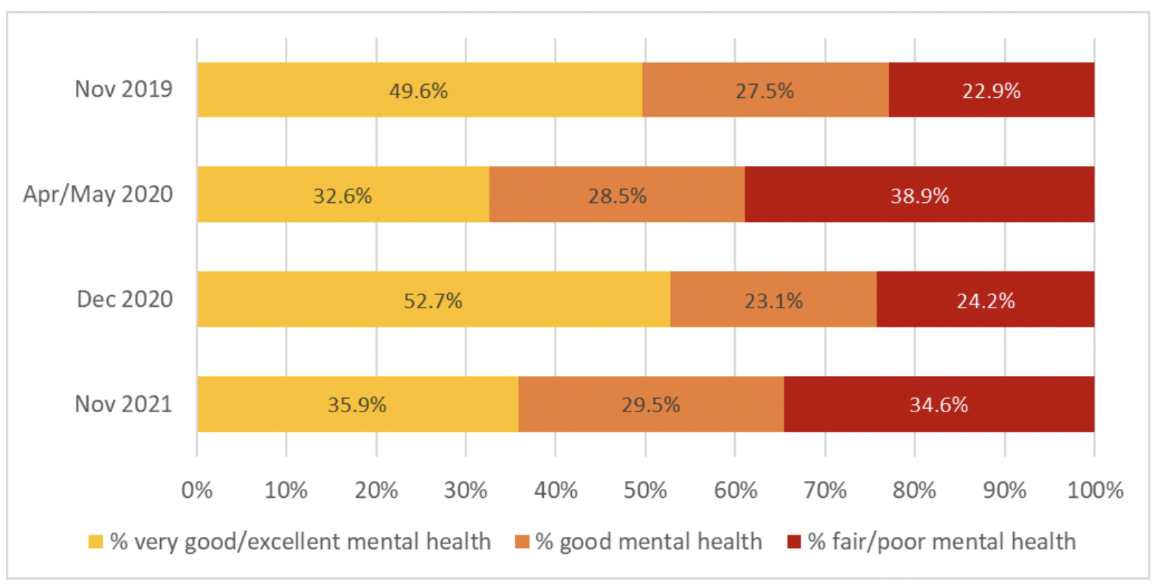

Solution can be

### **Exploring Multiple Domains with a ‘Wide’ View**

* **Goal:** Identify multi-linked indicators that capture broader impacts on wellbeing across domains.

**Proposal:**

**Correlate social media sentiment with wellbeing indicators** (e.g., safety, mental health) by analyzing spikes in negative sentiment during certain periods (e.g., lockdowns) and identifying which domains of wellbeing were most impacted.

# Social Impact of Psychological Research on Well-Being Shared in Social Media - Pulido CM, Mara LC, Ionescu V, Sordé-Martí T. Social Impact of Psychological Research on Well-Being Shared in Social Media. Front Psychol. 2020 Feb 26;11:135. doi: 10.3389/fpsyg.2020.00135. PMID: 32174862; PMCID: PMC7054436.

The result: **Evidence of Social Impact**: The research demonstrated real social impact as evidenced by its presence and discussion on social media. This indicates that the selected studies are effectively contributing to improving people's lives.

**Key Contributions**:

* **Quality of Relationships**: Research highlights the direct impact of the quality of relationships on lifelong health.q
* **Social and Intellectual Engagement**: Engagement in meaningful social and intellectual activities supports brain health.
* **Self-Rating of Mental Health**: Positive self-assessment of mental health contributes to future mental well-being, which is crucial for mental health treatments.
* **Technology in Mental Health**: Technology, including early detection of depression and more accurate identification of mental health issues, enhances treatment and prevention, promoting overall well-being.

**Alignment with Sustainable Development Goals (SDG 3)**: The findings align with SDG 3, which focuses on Health and Wellbeing for All. The research contributes to this goal by providing evidence of improved health and well-being.

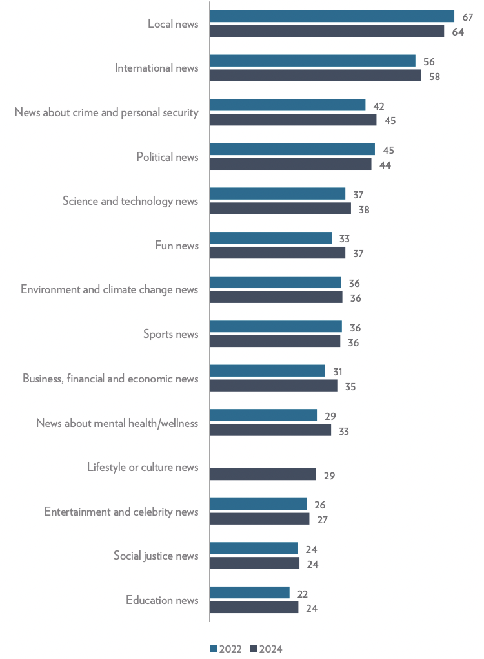

→ There is an increment of people interested in mental health/wellness.

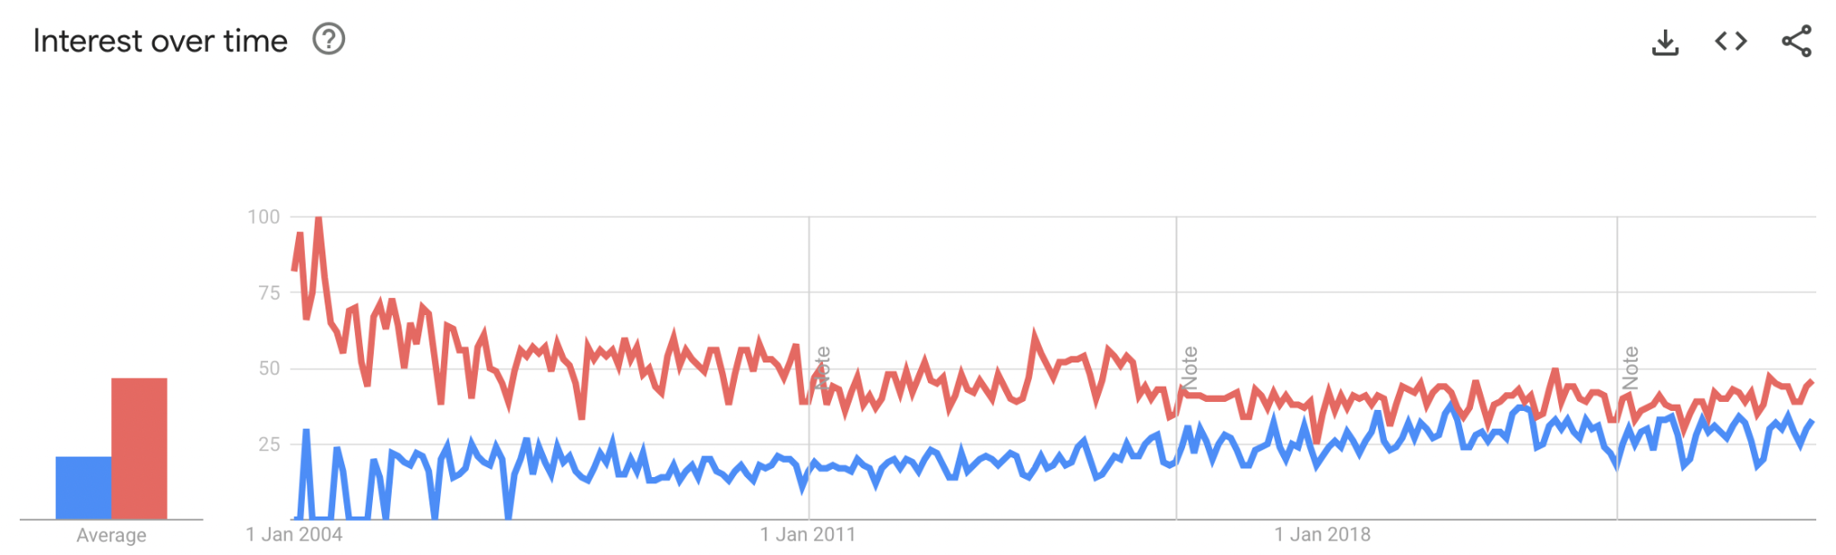

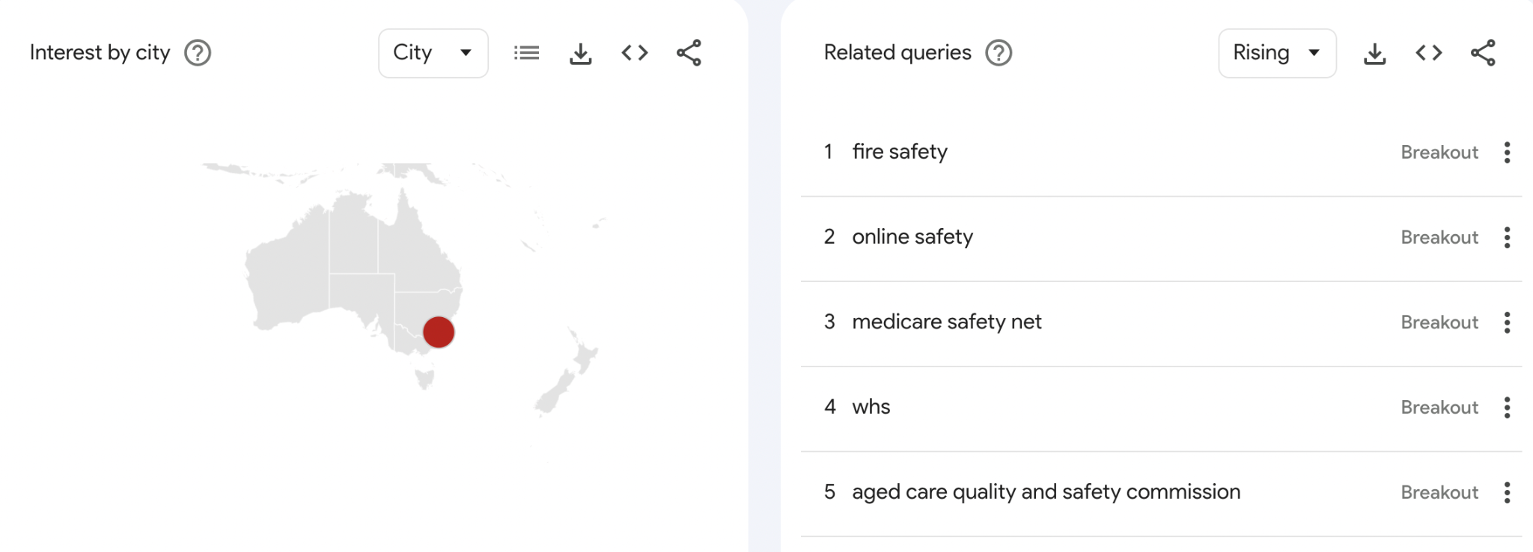

People mainly search for ‘FIRE’ safety

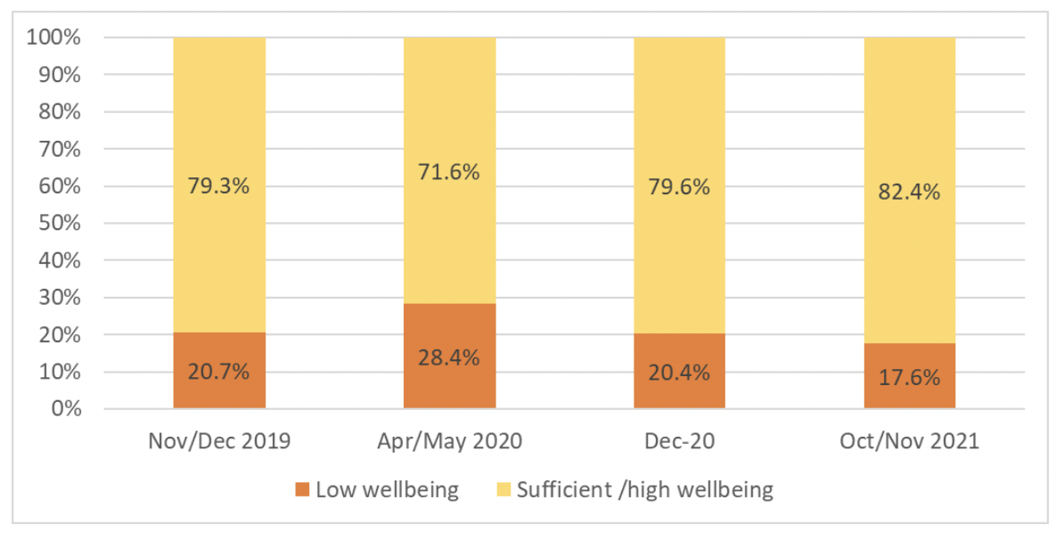

–People got low wellbeing score especially in 2020.

### **A Specific Domain with a Focused Approach**

* **Goal:** Dive deep into a specific domain to uncover insights.

**Domain Focus: Community Safety and Domestic Violence**

* Explore the **interaction between safety indicators** (e.g., crime data, domestic violence reports) and other wellbeing domains like **mental health** and **housing stability**.
* Integrate **data from domestic violence helplines**, **police reports**, and **emergency services** to map trends in domestic violence over time. Highlight the role of socioeconomic factors, employment status, and housing situations in predicting vulnerability to domestic violence.
* Apply **machine learning algorithms** to predict **high-risk periods or areas** for domestic violence, using data from environmental stressors (e.g., economic downturns) and the availability of community support services.

**Corelation between civic participation and wellbeing**

There are datasets for national civic participation and wellbeing (Canberra) - ACT but we find out it is hard to combine the two datasets because of different types of aggregated data.

Approach

Hypothesis

The higher the civic participation the better is the overall wellbeing?